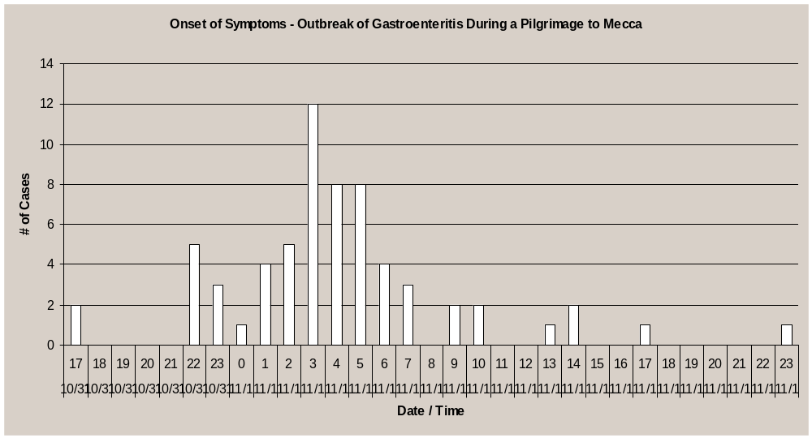
Graph 1 Epidemic Curve
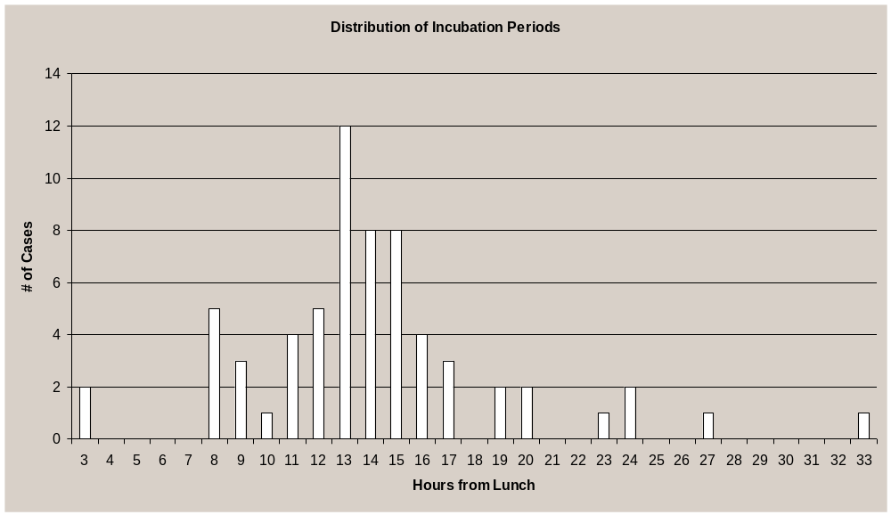

Graph 2 Distribution of Incubation Periods

